**Assignment 3.8**

1. **Create an HBase table named 'clicks' with a column family 'hits' such that it should be able to store last 5 values of qualifiers inside 'hits' column family.**

**create 'clicks',NAME=>'hits',VERSIONS=>5**

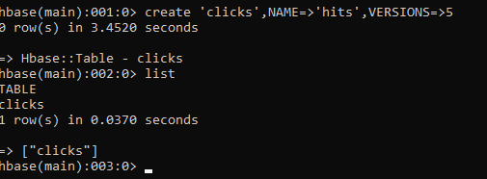

1. **Add few records in the table and update some of them. Use IP Address as row-key. Scan the table to view if all the previous versions are getting displayed.**

**put 'clicks','192.168.1.31','hits:num_of_hits','111'**

**scan 'clicks'**

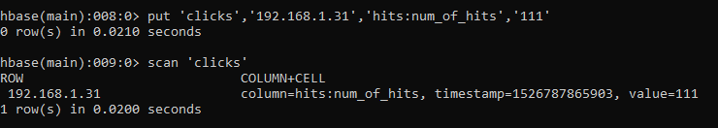

**put 'clicks','192.168.1.32','hits:num_of_hits','1123'**

**put 'clicks','192.168.1.34','hits:num_of_hits','3'**

**scan 'clicks'**

